Fast Fractal Image Block Coding Based on Local Variances
C. K. Lee and W. K. Lee
IEEE Transactions on Image Processing, Vol. 7, No. 6, pp. 888-891, June 1998
Abstract
In this paper we propose using the local variances of domain blocks to reduce the search space.
- Introduction
This method is based on the fact that two equal-sized image blocks cannot be closely matched unless their local means and variances are closely matched.
- Overview of Fractal Image Compression

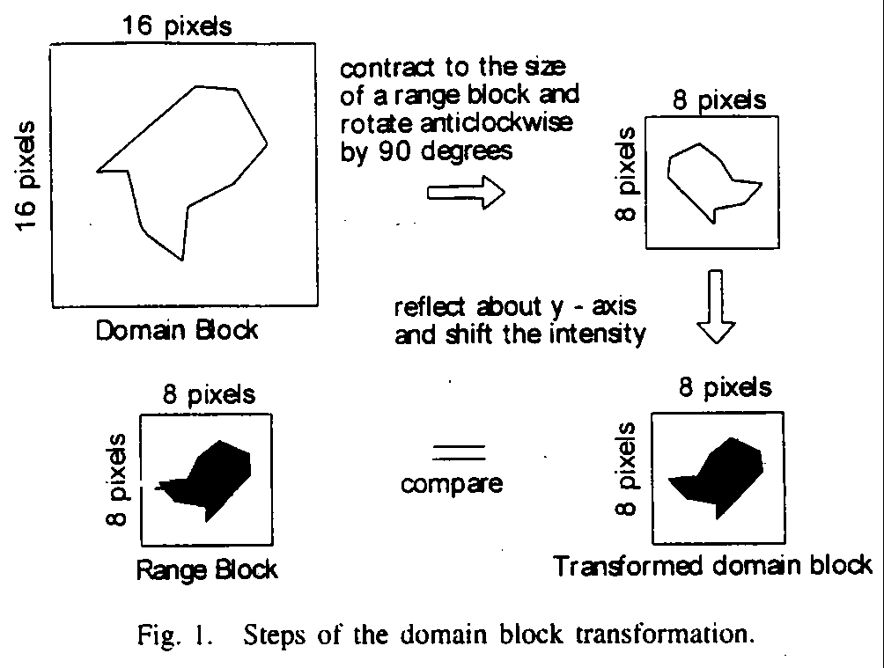
- Fast Encoding Algorithm
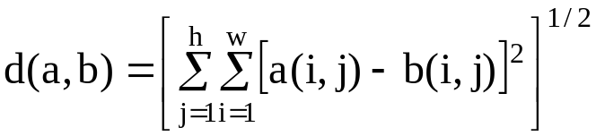
- Experimental Results

TABLE 1
Image | Apple |  | Bab |  | Lena
 | Exhaustive search | Search within a window | Exhaustive search | Search within a window | Exhaustive search | Search within a window
PSNR(dB) | 33.78 | 33.81 | 27.62 | 27.34 | 31.15 | 30.89
Compression Ratio | 10.25 | 10.34 | 3.6 | 3.7 | 5.69 | 5.78
Relative speedup | 1 | 10.34 | 1 | 10.79 | 1 | 8.06

TABLE 2
Window size in % of the domain pool | Average PSNR (dB)
Window size in % of the domain pool | Apple | Bab | Lena
4.7 | 33.04 | 27.13 | 30.06
6.3 | 33.03 | 27.25 | 30.09
7.8 | 33.02 | 27.30 | 30.11
9.4 | 33.02 | 27.34 | 30.12
10.9 | 33.01 | 27.36 | 30.11
- Conclusion
For the selected images, the search space can be reduced to around 5%, compared with exhaustive search, with a relative speed up. Also, the quality of the decoded images remains almost the same.
Created by : Chia-Hao Yang
Date : June 24, 1998

